Lecturer Feedback and Implementation Report
Module: PROG6212
Student Name: Fortunate Lukhele
Student Number: ST10443192
Date: 04 October 2025
This document provides evidence of lecturer feedback received during the development of the Claims System prototype and explains how each recommendation was implemented in the final WPF application.

1. Overview of System
System Overview – Contract Monthly Claim System
1. Introduction
The Contract Monthly Claim System is a desktop-based application designed to simplify and automate the process of managing and processing monthly payment claims submitted by university contract lecturers. The system replaces manual, paper-based claim submissions with a centralized digital solution that improves accuracy, efficiency, and transparency across multiple academic roles.
2. Purpose of the System
The purpose of this system is to:
- Provide a secure and user-friendly platform for lecturers to submit their monthly work claims.
- Allow academic managers, coordinators, and administrators to review, approve, or reject claims online.
- Automate data storage and retrieval using an integrated SQLite database.
- Maintain a record of all submissions, approvals, and payments for auditing and accountability.

3. System Users and Roles
The system supports multiple user roles, each with distinct privileges and interfaces:
Role | Responsibilities
Lecturer | Submits monthly work claims with details such as hours worked, hourly rate, and supporting documents.
Academic Coordinator | Reviews and validates claims from lecturers under their department before forwarding them for approval.
Programme Manager | Reviews claims submitted by coordinators and ensures they align with contractual policies.
Administrator | Manages user accounts, system data, and overall configuration of the application.

4. Key Features
- User Authentication: Secure login system with role-based access control.
- Claim Management: Lecturers can create, edit, and submit claims digitally.
- Approval Workflow: Multi-step review process by coordinators and managers.
- Automated Calculations: Calculates total claim amount based on hours and rates.
- Data Storage: Uses a SQLite local database for portability and reliability.
- Audit Trail: Keeps records of all submissions and status changes.
- Dashboard Interface: Each role has a dashboard summarizing their relevant tasks.
- Data Validation: Ensures all required claim details are provided before submission.
- Modern UI: Clean, responsive interface with gradient themes and hover animations.

5. Technology Stack
Component | Technology Used
Programming Language | C# (.NET WPF Application)
Database | SQLite (via Microsoft.Data.Sqlite)
UI Framework | WPF (Windows Presentation Foundation)
Styling | XAML with custom CSS-like styles
Data Access | Repository pattern implemented via DatabaseManager.cs
Password Security | SHA-256 hashing via PasswordHelper class

6. Workflow Summary
- Lecturer Login: Lecturer logs in securely.
- Claim Submission: Lecturer fills out the claim form and submits it.
- Coordinator Review: Coordinator reviews and validates the claim.
- Manager Approval: Manager approves or rejects claims based on policy.
- Admin Oversight: Administrator can monitor all activities and generate reports.

7. Benefits
- Eliminates paperwork and manual data entry errors.
- Saves time for both lecturers and administrators.
- Improves transparency and accountability in claim approvals.
- Provides an easy way to store, back up, and query historical claim data.
- Designed for scalability and future integration with payroll systems.

2. Lecturer Feedback Summary
Lecturer Feedback | How Feedback Was Implemented
Add a feature to allow lecturers to upload documents.
Show claim status clearly for tracking progress.
Include a section where lecturers can leave feedback.
Provide evidence of testing and reliability.

3. Screenshots of Implementation
Insert screenshots here to show each implemented feature:
• Claim submission form
• File upload dialog
• Approval interface
• Lecturer feedback section
• Unit test results console output

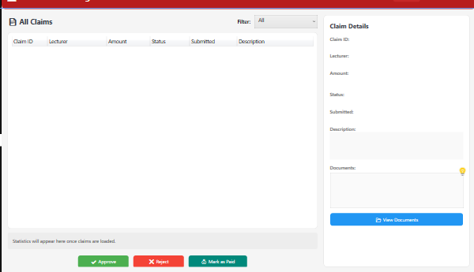

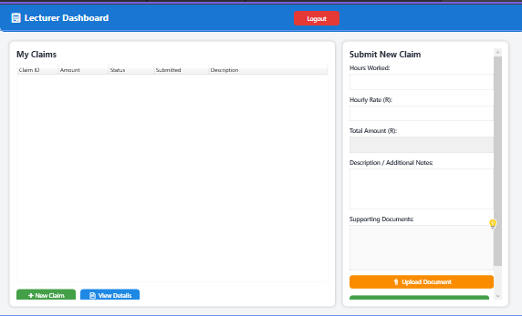4. GitHub Version Control Evidence

ContractMonthlyClaimSystemPart-2/ at main · ST10443192/ContractMonthlyClaimSystemPart-2

5. Conclusion
The Contract Monthly Claim System project effectively offers a secure, user-friendly, and productive platform for handling lecturer payment claims inside an academic institution. The system guarantees users and claims data storage dependability through features like user authentication, role-based dashboards, and audit by integrating a structured SQLite database. Logging improves both accountability and usability.

The entire development process prioritized scalability, code organization, and maintainability—all of which were accomplished through modular components like the DatabaseManager, UserSession, and dedicated. dashboards for various user roles, including administrator, lecturer, coordinator, and manager. The application's security and transparency are further enhanced by the use of helper classes like PasswordHelper and AuditLogger.

In the end, this project shows how contemporary software design concepts and C WPF technologies may be used together to simplify administrative procedures, minimize manual processing, and offer a claims management procedure that is more transparent and precise. In the future, it will be simple to add integration with institutional payroll systems, online submission tracking, or reporting capabilities to the system.

